**Issue Description:**

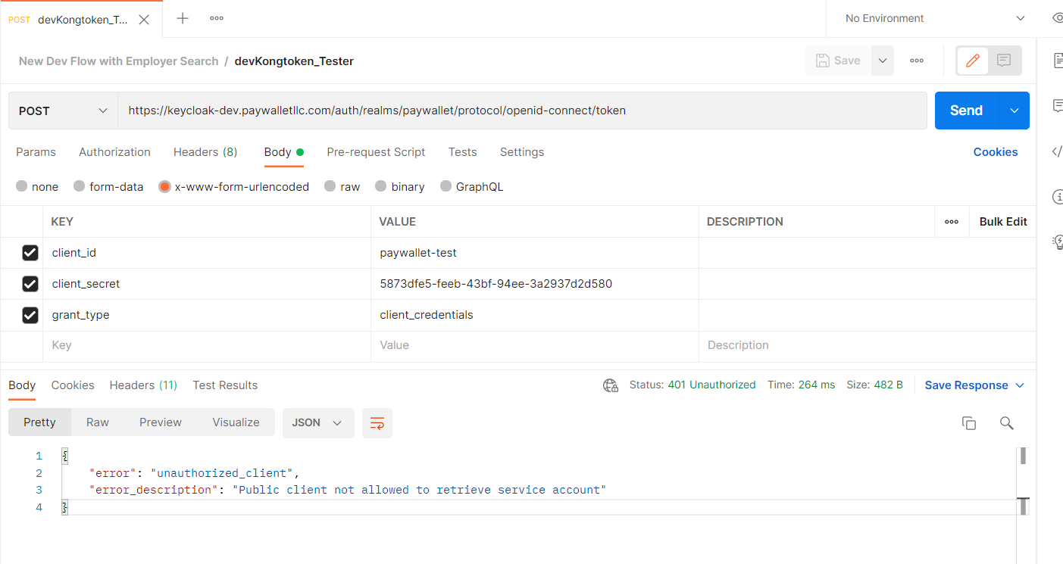

unable to generate a token getting error like "

{

    "error": "unauthorized_client",

    "error_description": "Public client not allowed to retrieve service account"

}

**Solution:**

1.Login into keycloak-dev.paywalletllc.com

2.On the left click on **realm** and select **paywallet** realm.

3.On the left click on **Clients** and select **paywallet-test** client

4.Under settings tab, see Access Type field and change it to confidential from Public

Note:

All client Access type should not be public, If it is their change to confidential.

5.Finally save and submit it.

